2001 Bio NSW
p10

Question 17 (3 marks)
(a) Label, on the diagram, ONE structural feature of the artery shown.
Artery
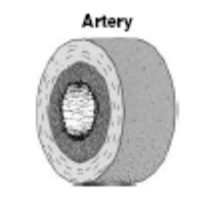
(b) How does the labelled feature relate to the artery’s function?
...............................................................................................................................
...............................................................................................................................
...............................................................................................................................
...............................................................................................................................
...............................................................................................................................
...............................................................................................................................
Question 18 (5 marks)
(a) Name TWO products extracted from donated blood, and state their uses.
...............................................................................................................................
...............................................................................................................................
...............................................................................................................................
...............................................................................................................................
(b) Propose ONE reason why scientists have now begun to develop artificial blood.
...............................................................................................................................
...............................................................................................................................

2002 Bio NSW
6 Metabolic processes in cells produce waste substances. These wastes are constantly
removed from the cells.
Why is waste removal essential for metabolic activity to continue?
(A) Waste products prevent the entry of essential nutrients into the cell.
(B) Metabolism of waste products produces chemicals that kill cells.
(C) Waste products alter the internal chemical environment of the cells and the
metabolic processes would stop.
(D) Retention of waste products causes cells to lose water by osmosis and they become
dehydrated.

page 11
Investigators gathered data on a group of 100 smokers for a period of 10 years. During
this time 12 people in the group developed lung cancer, two died in traffic accidents,
and three died of heart attacks. The investigators used this data to state that smoking
caused lung cancer.
Describe how this investigation could be improved.

page 17
The diagram shows a cell containing three pairs of chromosomes just prior to
a meiotic division.
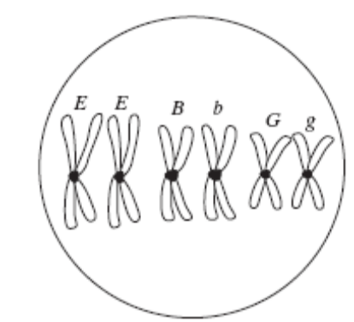
Assuming that random segregation occurs, construct a table that lists the possible
genotypes that could be produced and states the expected frequency for each
genotype.

page 18
The diagram represents a nephron which is the functional unit of the kidney.
Nephrons make urine by:
• filtering small molecules and ions from the blood;
• reabsorbing the needed amounts of useful materials.
Surplus or waste molecules and ions flow out as urine.

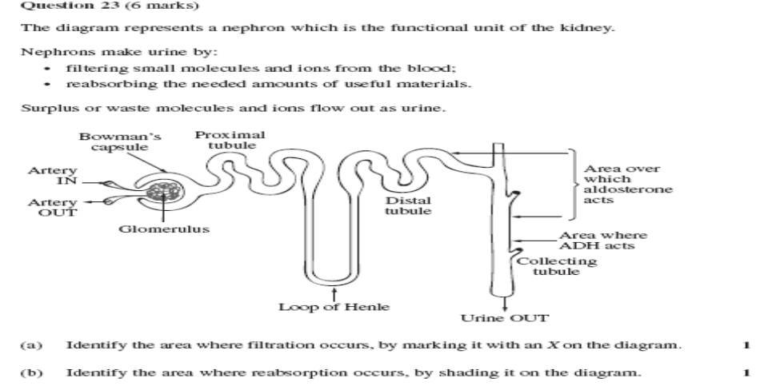
(a) Identify the area where filtration occurs, by marking it with an X on the diagram.
(b) Identify the area where reabsorption occurs, by shading it on the diagram.

2003 bioNSW
4 What are three products extracted from donated blood?
(A) Oxygen, water and urea
(B) Red blood cells, salts and oxygen
(C) Plasma, platelets, and red blood cells
(D) Platelets, hormones and amino acids

7 The graph represents the relationship between substrate concentration and enzyme
activity for a metabolic reaction.
Which statement is an accurate interpretation of the graph?
(A) Point A is the maximum level of enzyme concentration.
(B) Increasing substrate concentration beyond Point A will not increase the rate of reaction.
(C) Increasing substrate concentration beyond Point A will increase the rate of reaction.
(D) Increasing the enzyme activity beyond Point A will not increase the rate of reaction.

Question 20 (3 marks)
The diagram shows various forms of radiation that are part of the electromagnetic
spectrum.
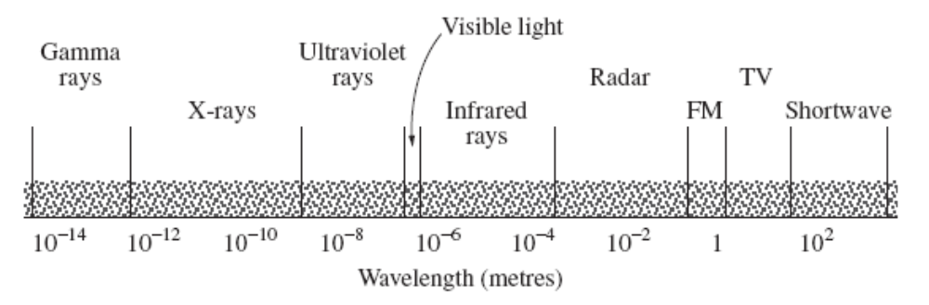
(a) Select ONE form of radiation that is considered to be a mutagen.
...............................................................................................................................
(b) Describe evidence that supports the mutagenic nature of the selected form
of radiation.

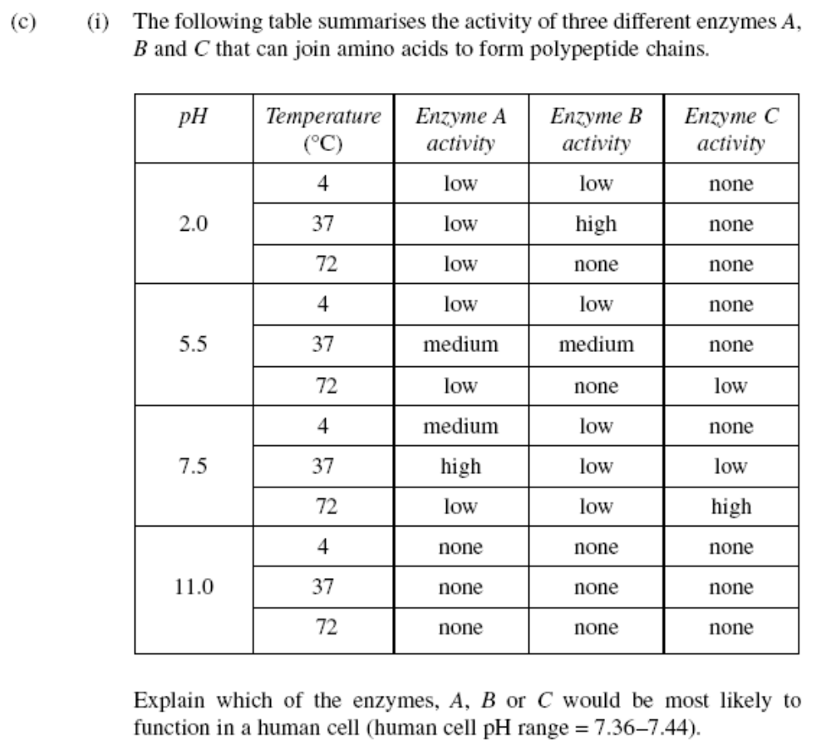

2004 bio NSW
5 The diagram below illustrates one process that occurs as part of an immune response.
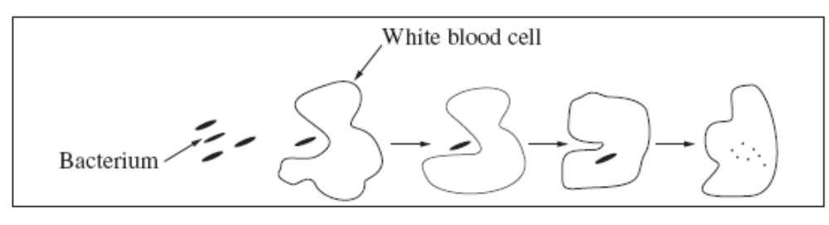
What process does the diagram illustrate?
(A) Cytokinesis
(B) Inflammation
(C) Osmosis
(D) Phagocytosis

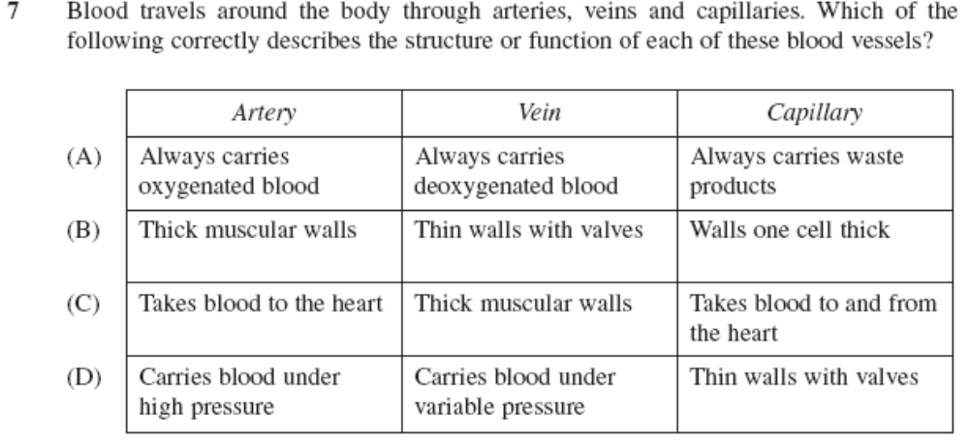

8 Which statement best describes a function of nephrons?
(A) Filter waste products from the blood
(B) Remove carbon dioxide from the blood
(C) Collect urine from the blood
(D) Remove the waste products directly from the cells in the blood

14 Why is accurate replication of DNA important?
(A) It leads to cell differentiation.
(B) It maintains genetic information.
(C) It allows for evolution of the species.
(D) It enables cells to modify their proteins.

15 ‘Generally, gametes produced by an organism will not be identical.’
Which of the following does NOT influence this genetic variability of gamete formation?
(A) Mutation
(B) Sex linkage
(C) Independent assortment of alleles
(D) Crossing over in homologous chromosomes

